**DLAP Test Cases/Scenarios 1:12pm, 08122020**

**Updated on 12/14/2020**

### *Scenario1: External users (IAL1) should able to verify his/her IAL2 information (upload ID from Laptop)*

1. When user click login on DLAP Home page, users should be redirected to Connect/Login.gov for authentication when they login from DLAP.
2. When user click the login page on DLAP home page user will be navigated to the login.gov “Term and Conditions” page,
3. When user click “Accept” button, user will be navigated to the credential page.
4. When user enter valid credentials and click sign in, user will be redirected to the IAL2 Identity verify page.
5. When user click the checkbox and click “Continue” button, user will be navigate to the Upload ID page.
6. When user click “Upload from your computer” link, user will be navigated to the Upload front of ID page.
7. When user click choose file button, the windows document opened. When user chose the document and upload it, system asks to upload the back of ID page.
8. When cancel the ID verification, user will see cancellation message.
9. When user click Continue button, user will navigate to the SSN entry page.
10. When user enter wrong SSN number click “Continue”, system will navigate to the Verify Information page.
11. When user click “Continue” user will get warning message.(Negative step)
12. After user click try again, system will be navigate back to the SSN entry page.
13. After enter valid SSN, the system will navigate to the verify information page again.
14. When user clicks the “Continue” button, system will redirect user to ID verification page.
15. When user clicks continue the system will navigate user to the phone verifying page.
16. When user enter wrong phone number, user will get warning message. (Negative step)
17. After enter correct phone number and continue, system will navigate the user to reenter password page.
18. After user enter valid password, system will navigates the user to personal key page.
19. After copy personal key and click continue button, system will navigates the user to enter personal key page.
20. When user paste/enter the personal key and clicks the continue button, system will navigates the user to the identity verified/ Agree and continue page.
21. When user click agree and continue, system will navigate the user to the DLAP home page.

### *Scenario2: External users (IAL1) should able to verify his/her IAL2 information (upload ID from phono)*

1. When user click login on DLAP Home page, users should be redirected to Connect/Login.gov for authentication when they login from DLAP.
2. When user click the login page on DLAP home page user will be navigate to the login.gov “Term and Conditions” page,
3. When user click “Accept” button, user will be navigate to the credential page
4. When user enter valid credentials and click sign in, user will be redirected to the IAL2 Identity verify page.
5. When user click the checkbox and click “Continue” button, user will be navigate to the Upload ID page
6. When user click “Use your phone” link, user will be navigated to the “Take photo with a phone” page.
7. When user enter the phone number and click “Continue” button, the system will send a link to user, and user able to take a photo of ID’s front, back and selfie.
8. When user complete take a photo of ID and selfie, system navigate back user to laptop and ask enter SSN.
9. After enter valid SSN, the system will navigate to the verify information page.
10. When user clicks the “Continue” button, the system will navigate the user to “We have verified your Information….”
11. When user clicks continue the system will navigate user to the phone verifying page.
12. After enter correct phone number and continue, system will navigate the user to reenter password page.
13. After user enter valid password, system will navigates the user to personal key page.
14. After copy personal key and click continue button, system will navigates the user to enter personal key page.
15. When user paste/enter the personal key and clicks the continue button, system will navigates the user to the identity verified/ Agree and continue page.
16. When user click agree and continue, system will navigate the user to the DLAP home page.

### *Scenario3: External users (IAL2) should able to redirect from SBA connect to DLAP*

1. When user on the home page of SBA Connect and click DLAP link, user will be redirected to the sign in or switch emails.
2. When user click “sign in” button, user will navigated to the DLAP home page.

### *Scenario4: External users (IAL1) should able to verify his/her IAL2 information*

1. When user on the home page of SBA Connect and click DLAP link, user will be redirected to the sign in or switch emails
2. When user click sign in, user will be redirected to the IAL2 Identity verify page, and continue IAL2 verification.

### *Scenario5: External users (new user) should able to cancel his/her IAL2 information*

1. When user click the login page on DLAP home page user will be navigate to the login.gov “Term and Conditions” page,
2. When user click “Accept” button, user will be navigate to the credential page.
3. When user enter valid credentials and click sign in, user will be redirected to the IAL2 Identity verify page.
4. When user click the checkbox and click “Continue” button, user will be navigate to the Upload ID page
5. When user click “Upload from your computer” link, user will be navigated to the Upload front of ID page.
6. When user click choose file button, the windows document opened. When user chose the document and upload it, system ask upload back of ID page.
7. When cancel the IAL2 verification, user will see “Are you sure you want to cancel?” message.
8. When user click “Yes, cancel”, user will be navigated to the cancel verification information page.
9. When user click “back to connect Staging”, user will navigate back to SBA connect staging Home page.

### *Scenario6: External users after failed IAL2 verification 3 times should able to go back SBA connect (Old)*

1. When user fails to verify their IAL2 information, user is able to try 3 times.
2. If user will fails all three time, when user click the link “Get help Connect staging” will be able to go back SBA connect. (login.gov newly updated)

### *Scenario7: When External user fails to verify SSN and DOB during verify IAL2, the Profile page should be editable so that user can edit SSN and DOB with Equifax (the new added feature)*

1. When user fails to verify DLAP IAL2 information.
2. Then the user is able to go to the Profile Information page, the DOB and SSN fields should be editable.
3. (When user enter their DOB and SSN and click the “Submit” button. When it is successful, success message will pop up.)
4. When user fails the message below shows up on the top of the screen “You failed verification from Equifax. You have one more try left. Please enter your information below to retry the verification”
5. When user fails to verify second time with Equifax, than the system shows the message “Your profile information has been updated. However your information was not verified by Equifax”.

### *Scenario8: When External IAL2 user login to SBA Connect, the Profile page shouldn’t be editable so that user can edit SSN and DOB with Equifax (the new added feature)*

1. When IAL2 user login to SBA Connect from DLAP application, the user able to see the “Profile Information” page.
2. Then the user is able to see the Profile Information page, when user click the “Continue” button, the system navigate the user to the SBA connect home Page.

Extra added a negative test and screenshots for it.

Negative Testing for IAL2/Equifax verification 9:20am, 10292020 (Updated on 12/14/2020)

Negative testing Pass

Email:

**Scenario: IAL 1 User login from SBA Connect to the DLAP application (Negative)**

1. User on the SBA Connect Home page, when user clicks the DLAP link, the user will be navigates to the IAL 2 verification screen.

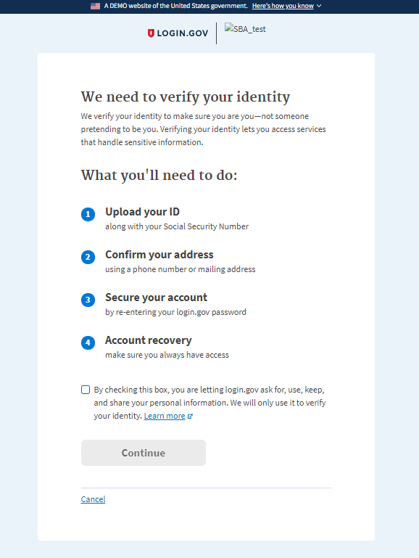

1. When user click the ‘Cancel’ button, the system will be navigates user to the confirm cancellation page.

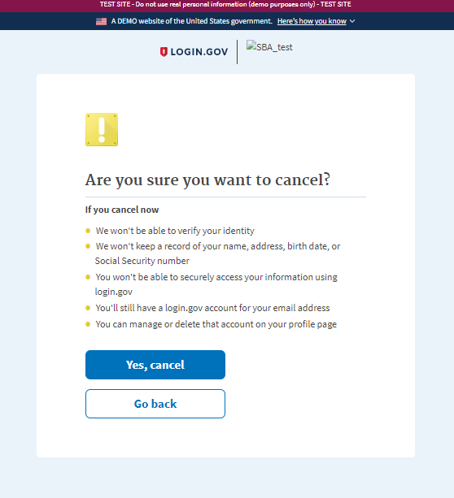

1. When user click “Yes, cancel” button, the user will be navigates to the confirmation page.

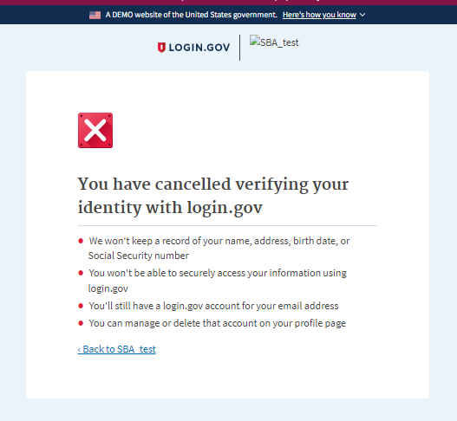

1. When user click ‘Back to SBA test’ link, the user will be navigates to the ‘Profile Information’ page. The user will able to see the message ‘You failed verification from login.gov Please enter your information below to verify with Equifax’.

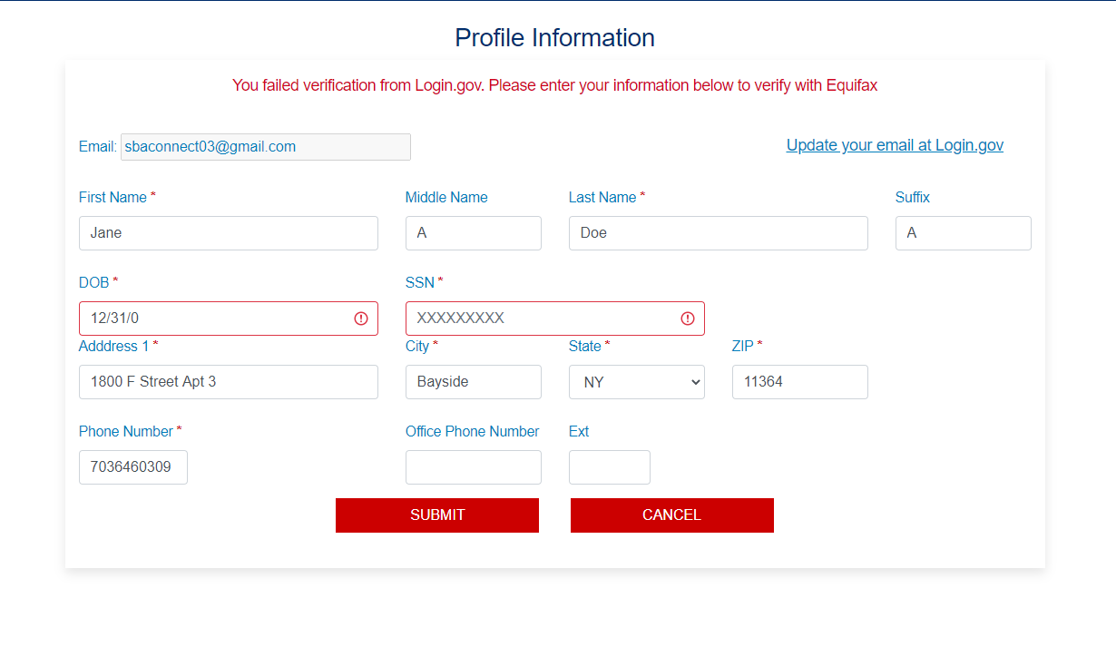

1. When user fill these information and clicks the ‘Submit’ the user will able to see the message ‘You failed verification from Equifax. You have one more try left. Please enter your information below to retry the verification’.

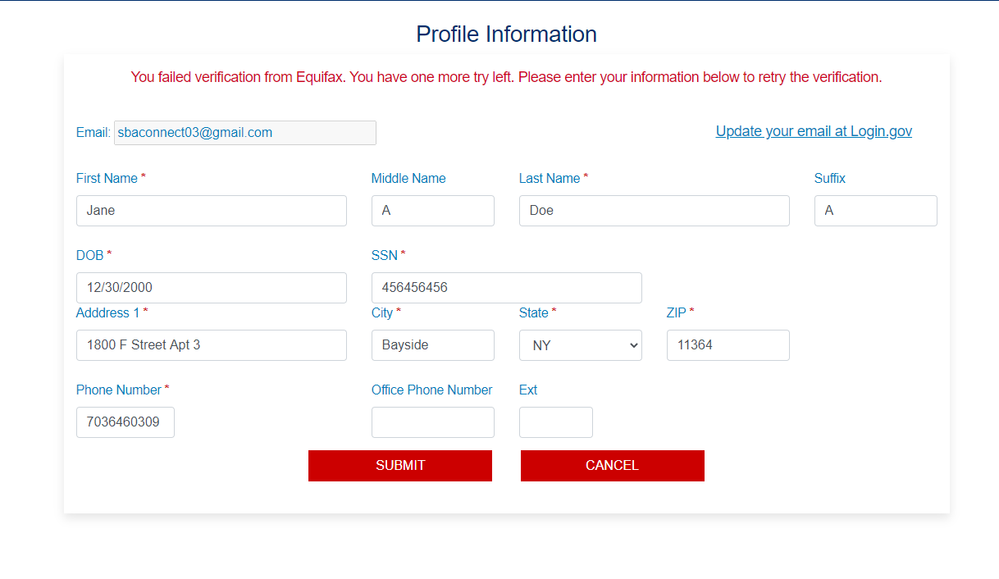

1. When user retry with invalid SSN &DOB, user will able to see the message ‘Your profile information has been updated. However, your information was not verified by Equifax’.

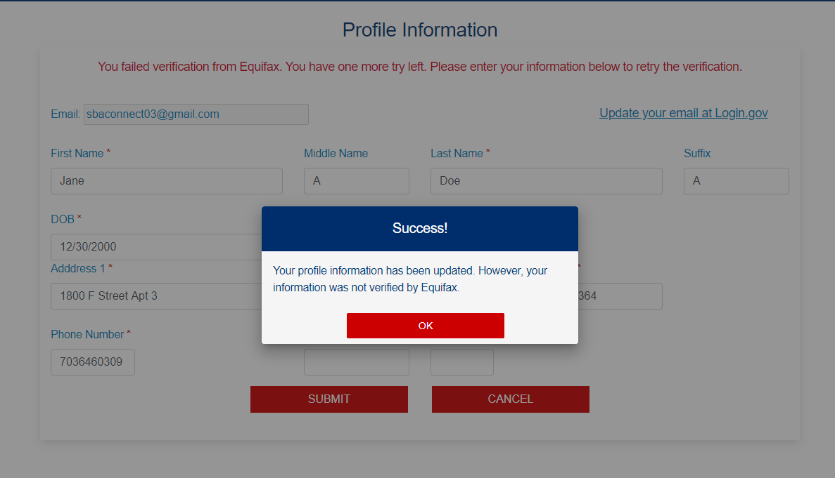

1. When user click the ‘Ok’, then the system will be navigates to the SBA connect Home page.

